## Merchant

Demo date: Nov 15, 2024  
Scoping start date: Jun 13, 2024

MSA Signature Date: Nov 26, 2024  
Onboarding Kick Off Date: Dec 4, 2024

[If Exists] Opt Out Date:  
Go Live Date: Mar 1, 2025

GTM POC: Nick  
Implementation POC: ArielDani

ERP: QBO

Tax Integration: QBO Hard Coded Taxes

### 

### Key people at Merchant

### Head of Finance and Operations: Jerry Thomas - <https://www.linkedin.com/in/jerry-thomas/>

* COO: Asish Walia - https://www.linkedin.com/in/ashishwalia1/
* Billing POC

### Etc.

### 

| Notes Sections [Ops International Team to Ignore] *(AE/ Implementation to fill)*   * Bill for # of hours worked by their Lawyers. Sometimes this is tiered. * Is there any important merchant relationship information? Ashni’s uncle is COO. GS built a great relationship during sales process 1) What is the merchant temperament? * Jerry is a little wishy washy but easy to work with. Genuinely just has a lot on his plate and is hesitant to take on projects 2) Is there a key POC: (i.e.: who is the buyer/decision maker?) * Jerry and Ashish 3) What are the Tabs features that the key POC cares about? * Contract Management, automated invoicing, Rev Rec, and ARR Reporting |
| --- |

### 

### Company summary *(AE to fill)*

Lawtrades is a legal marketplace business doing $12 Million in revenue & profitable. The team is super lean (<12 FTE in the US) & they need to use an invoice factoring service that they pay interest on the longer it takes to collect client bills.

https://www.lawtrades.com/

Goals (North star)  
*(AE/ Implementation to fill)*

What is the merchant's goal? What pain are we solving? Why are they buying Tabs?  
Automating revenue workflows without the need to increase headcount. They have terrible DSO and pay interest on overdue invoices. Currently this is ~60 days and need to get it down to Net 30

Is there an opt out clause? If so, what is the merchant looking for so they do not exercise it?  
No

### Billing model *(AE/ Implementation to fill)*

* Are there unique things about the customer creation process for this merchant?
  + N/A
* Information on how merchant bills
  + # of Hours worked by their team
* How contract is broken up
  + N/A
* One off things to know about the merchant
  + They factor their invoices through OatFi. This is integrated with their existing stack.

### Contract Processing Steps *(Implementation/Success to fill)*

Steps to process

1. Find the section called Statement of Work
2. There will be a checked option of one of the following, please follow the instructions. The selected option will have an X next to it:

* Normal Hourly Fee
* Discounted Hourly Fee
* Upfront Flat Fee + Hourly Fee

1. Defaults:
   1. Start Date:
      1. Date listed in SCOPE OF WORK TERM. If no date listed, default to the date the contract was uploaded to garage.
      2. If any contract has a start date prior to 2024, Use the first of the month of the most recent open period.

**Example:**

1. Contract starts 10/1/2023
2. QBO accounting period is closed until 4/30/2025
3. Use 5/1/2025 as the contract start date
   1. Months of Service/Periods: 12 unless otherwise listed
   2. Frequency: Monthly or Semi-monthly
      1. Default to monthly unless the contract specifies that it is billed semi-monthly
   3. Net Terms: 30 unless otherwise listed
   4. For all USAGE BTs, select “Bill last of period”
   5. Event types:
      1. **A new event type will need to be created for each new contract, because the name of the event type is the name of the engaged legal professional**
   6. The integration item is the name of the legal professional in the contract. If a new contract comes in and the integration item has not yet been created, leave blank and flag to the team so we can let the merchant know.
   7. ****all complimentary hours should be billed as a negative discount billing term (screenshot below). This will be equal to the hourly rate that has been specified x the number of hours.
      1. The billing and service dates should be the same as the hourly term
      2. The frequency will be the same as the hourly BT
      3. # of periods will be 1
      4. Integration item should be the same as the lawyer



### **Normal Hourly Fee** [**Garage Example here**](https://garage.tabsplatform.com/prod/contracts/875244c6-8397-4a83-b218-04465407ffd6/terms/revenue)

**This is a standard Has Minimum structure, with no minimums or thresholds.**

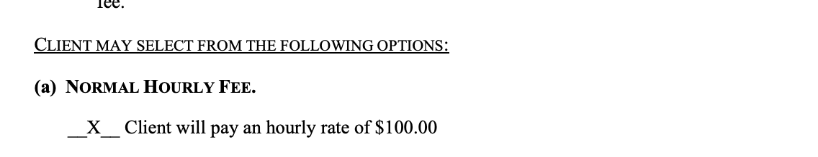

* Item Name: Name the Engaged Legal Professional listed
* Integration Item: Name the Engaged Legal Professional listed, see example below
* Description: Rate, format “$100/hr”

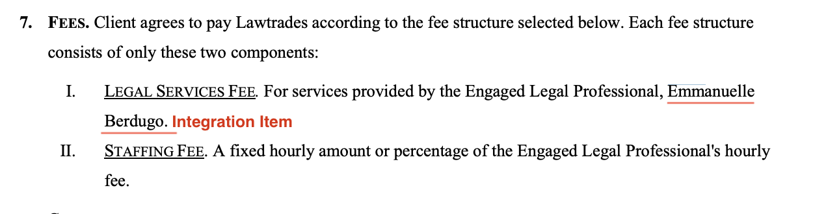

* Billing type: Unit Price
* Total Price: Found in contract, use hourly rate
* Event to track: Name the Engaged Legal Professional listed
* Rev schedule start date: Found in SOW Work Term, default to 1 year unless specified otherwise, if
* BT start Date: start on the 1st of the month of the start date of the SOW (for monthly or semi-monthly)
* Periods: Length of service in months, +1 if SOW start date is not on the 1st or 16th (because the BT start dates are backdated slightly per above instructions)
* Frequency: Monthly (Unless semi-monthly is specified)
* Net terms: 30 (unless otherwise specified
* Billing Timing: Bill last of period

### **Discounted Hourly Fee** [**Garage Example**](https://garage.tabsplatform.com/prod/contracts/a8754ead-d896-42a5-9c9b-24d4b63a1015/terms/revenue)

**This option usually includes a minimum of a certain amount of hours.**

* Item Name: Name the Engaged Legal Professional listed, see example below
* Description: Rate, format “$100/hr”

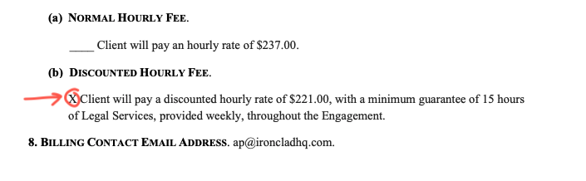

* Integration Item: Name the Engaged Legal Professional listed, see example below

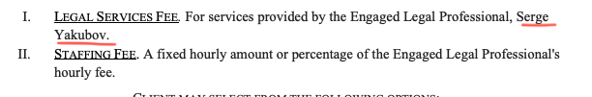

* Billing type: Unit Price
* Total Price: Found in contract, use net hourly rate without discount noted
  + Ex: Price fo the above example is 221, not 237 w/$16 discount
* Event to track: Name the Engaged Legal Professional listed, see example below
* Rev schedule Start Date: Found in SOW Work Term, default to 1 year unless specified otherwise
* BT start Date: start on the 1st of the month of the start date of the SOW (for monthly or semi-monthly)
* Periods: Length of service in months, +1 if SOW start date is not on the 1st or 16th (because the BT start dates are backdated slightly per above instructions)
* Net terms: 30 (unless otherwise specified)
* Billing Timing: Bill last of period

**Once the BT is created, go to the Usage AI tab. Configure that form as follows:**

1. Move switch to **Has Minimum**
2. Has use minimum = **Toggle ON**
3. Included products = **Only select the hourly usage BT** (this will be the lawyer’s name)
4. Minimum period = **Individual billing period**
5. True up to meet minimum = **Toggle ON** (default setting)
6. Minimum is fixed = **Toggle ON** (default setting)
7. Adjustment name = **Minimum hours requirement**
8. Integration item = same integration item used in the BT (Name of legal professional)
9. Amount = **hourly rate from the contract * (weekly minimum hours*# of weeks in billing period)**. For the example below:
   1. If semi monthly: 221*(15*2)=6630
   2. If monthly: 221*(15*4)=13260
10. Service period = Check on **Service period same as contract** (default setting)

**BE SURE TO HIT SAVE!**

**Example:**

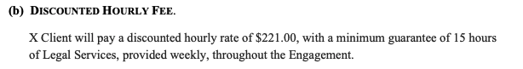

### **Upfront Flat Fee + Hourly Fee** [**Garage Example**](https://garage.tabsplatform.com/prod/contracts/7c294ee7-606a-4769-83ac-ecf4baa3a259/terms/revenue)

* Create two Rev Schedules
  + Rev schedule #1 for upfront purchase
    - Item Name: Upfront Fee
    - Description: Rate, format “$100/hr”
    - Integration Item: Name of Engaged Legal Professional
    - Billing type: Flat
    - Total Price: Total price listed that is not the hourly fee
      * Sometimes, this is listed by listing the total number of hours allocated with the hourly rate, so it will need to be calculated
        + Example #1 below = $18000 upfront fee
      * Other times, a price might be specifically listed. This might also include a discount or credit from a previous contract. In this case, use the total listed as the up front payment
        + Example #2 below = $95800 upfront fee
    - Start Date: SOW Term Start
    - Frequency: 1 + Length of term in contract
    - Billing Timing: BIll first of period (default)
* Rev schedule #2 for hourly fee
  + Item Name: Name of Engaged Legal Professional
  + Description: Rate, format “$100/hr”
  + Integration Item: Name of Engaged Legal Professional
  + Billing type: UNIT
  + Total Price: Total price listed that is the hourly fee
    - Sometimes, the hourly fee is listed in a **POST-USAGE RATE** section, where the hourly fee for overages is different than the hourly fee used to calculate the u-front price. **If this exists, be sure to use this rate**
      * Example of this is below, post usage rate = 191, even though the rate used for the up-front payment is 171
  + Rev schedule Start Date: Found in SOW Work Term, default to 1 year unless specified otherwise
  + BT start Date:
    - Default to **monthly** frequency for all up front payments
    - Start on the 1st of the month of the start date of the SOW
  + Periods: Length of service in months, +1 if SOW start date is not on the 1st or 16th (because the BT start dates are backdated slightly per above instructions)
  + Frequency: Monthly (Unless semi-monthly is specified)
  + Net terms: 30 (unless otherwise specified
  + Billing Timing: Bill last of period

**Once the BT is created, go to the Usage AI tab. Configure that form as follows:**

1. Move switch to **Has Threshold**
2. Included products = **Only select the hourly usage BT** (this will be the lawyer’s name)
3. Threshold period = **Full service term** (default setting)
4. Charges overage = **Toggle ON** (default setting)
5. Adjustment name = **Prepaid hours**
6. Integration item = **same integration item used in the BT** (Name of legal professional)
7. Amount = **hourly rate from contract * # of hours allocated**. This will often be the same as the total up front payment.
   1. For Example #1 below:
      1. 180*100=18000
   2. For Example #2 below:
      1. 171*800=136800
      2. 171 is used instead of 191 because that is the rate for the numbers initial allocated, whereas the 191 is only the overage rate.
8. Service period = Check on **Service period same as contract** (default setting)

**Sometimes for up-front contracts, if all of the hours are used up, the customer will add more, which is done via email. To process this:**

1. Go to the original customer (The customer can be identified by their email address)
2. Add new upfront payment BT (same requirements as above)
3. If the original usage RS/BT is over or has less than 6 months left, extend another year (unless a different time frame is specified in the email)
   1. If the rate also changes per the email, update the price on the BT as well
4. In the Usage AI, update the threshold to the new upfront payment amount

Example of an email thread for this:

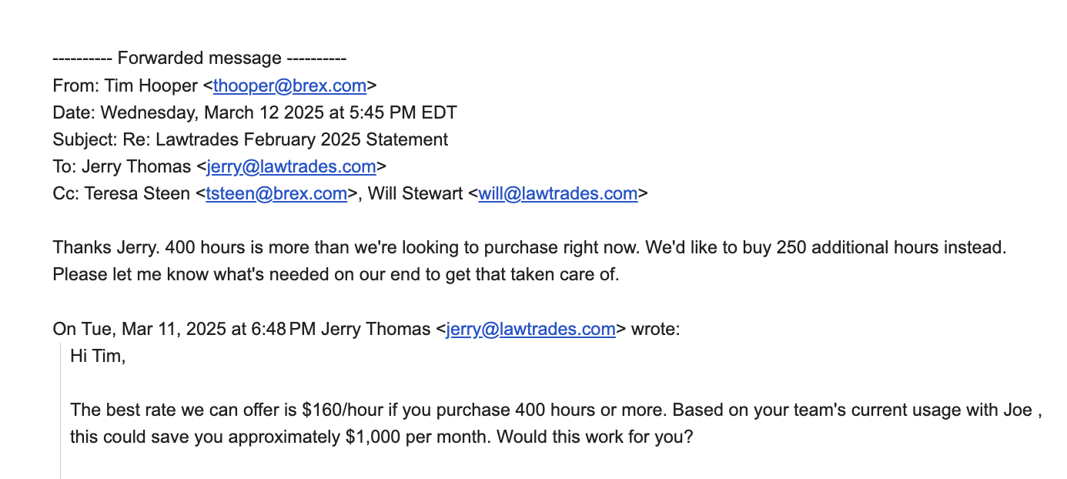

**EXAMPLES OF UPFRONTS**

**Example** **#1**

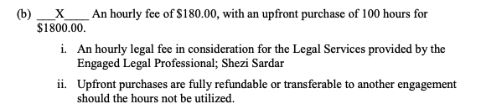

**Example #2**

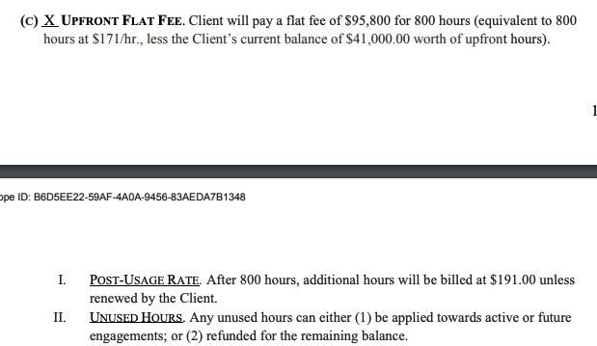

[**LOOM VIDEO OF OUR MEETING THAT WALKS THROUGH THESE STEPS**](https://www.loom.com/share/173f81cb33cb4bd88aac6719653798e9?_hsenc=p2ANqtz-9gpMsiz1xC2-ERxIpJdJd1LeQmBg_8hJczADoqwILECJ5JR3qaL7HrUFqsY_J8Nwz8Zl2hTWFl6HHxAdFBcJrzLbHptA&_hsmi=325882948&utm_content=325882948&utm_medium=email&utm_source=hs_email)

Anything to ignore in contracts?

1. Specifics processing things the merchant has requested that may differ by contract (e.g. always back-date invoice date to final day of the month)
2. Default Service Term
   1. If None Listed, Ops Default is 1 Year
3. Default Net Payment Terms
   1. Default 30
4. Default Billing Frequency
   1. If None Listed, Ops Default is Monthly
5. How do we handle taxes as a line item?
   1. If None Listed, Ops Default is every tax line item becomes a BT

### Events Processing (if necessary) *(Implementation/Success to fill)*

* Detailed above in processing instructions

Integration Items Processing (if necessary)  
*(Implementation/Success to fill)*

* Detailed above in processing instructions

Post Processing Communications (if necessary)  
*(Implementation/Success to fill)*

* Does the Ops Team need to notify anyone on the team re: completion of processing batches in Implementation or Active phase?
* Who needs to be notified and when?
  + Example:
    - Who: Customer Success [Azmat Aziz] needs to be notified
    - Where: Messari internal merchant channel
    - When: contracts are processed [Merchant Phase: Active]

### Customer Information *(Implementation/Success to fill)*

* Any important information on specifics customers of this merchant
  + Special memo’s certain invoices require
  + Invoice changes due to merchant/customer relationship

### Feature Requests *(AE/Implementation/Success to fill)*

* OatFi Integration
  + They factor their invoices through OatFi to get cash upfront then payout Oatfi with interest when invoices are paid
  + Need Cash upfront - they have very bad DSO of ~60 days
  + Timeline is March. Deepak and GS gave the thumbs up after meeting with OatFi team pre MSA
* Professional Services
  + They want Tabs to run all of their billing rather than hiring a billing manager
  + GS owning this by devoting resources to acting as a AR clerk
  + Potential upsell in March

### Rewatch Calls *(AE/Implementation/Success to fill)*

* 6/13/24 - First Intro Call
  + https://tabs.rewatch.com/video/ga7411e2p5ap0ybo-jerry-nicholas-meeting-june-13-2024
* 6/26/24 - Custom Demo with Jerry
  + https://tabs.rewatch.com/video/2ss3x5h36acypq8u-jerry-thomas-and-nicholas-gatti-june-26-2024